DEPARTMENT OF COMPUTER ENGINEERING
CLOUD COMPUTING & FRAMEWORKS
EXPERIMENT NO. 09
CASE STUDY: EDGE COMPUTING AND FOG COMPUTING IN SMART MANUFACTURING / INDUSTRIAL IOT
STUDENT DETAILS
Name: Sayyad Faizan
Class/Batch: TE CO - I 03
Roll No.: 24DCO11
Academic Year: 2024-2025
Subject: Cloud Computing & Frameworks (CCF)

1. Abstract
Edge computing and fog computing are distributed computing approaches that move selected computation closer to where data is produced. This case study considers a smart factory scenario in which industrial sensors and machines generate continuous operational data. Edge devices detect urgent events near each machine, while a local fog node combines information across the factory floor, and the central cloud performs long-term predictive maintenance AI model training.
2. Introduction & Definitions
2.1 What is Edge Computing?
Edge computing processes raw sensor data directly on or near the physical machine or edge device (microcontrollers, PLCs, smart sensors) that generates it, enabling sub-millisecond real-time actions.
2.2 What is Fog Computing?
Fog computing acts as an intermediate architectural layer situated between edge devices and centralized cloud datacenters. Local fog nodes aggregate and correlate telemetry across multiple edge devices on the local area network.
3. Smart Factory System Architecture
The proposed industrial IoT architecture distributes computing workload across three tiers:
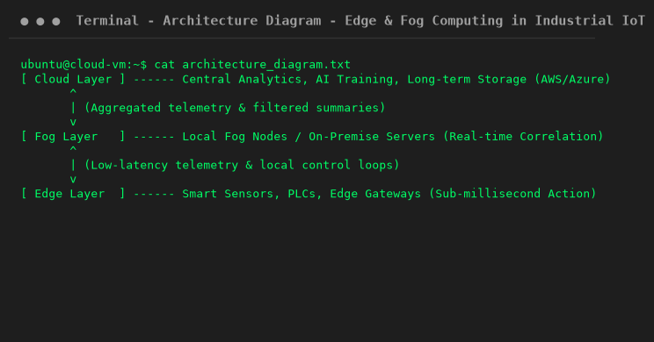
3.1 Latency and Processing Focus
System component operational parameters and response times:
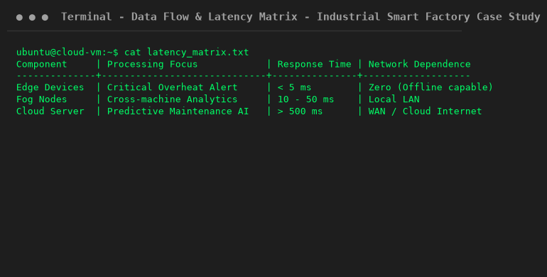
4. Key Benefits & Challenges
• Latency Reduction: Safety cutoffs execute in < 5 ms at the edge layer.
• Bandwidth Efficiency: Only aggregated summaries are transmitted to cloud datacenters.
• High Availability: Local production line functions continue seamlessly during internet outages.
5. Viva Questions & Conclusion
Q1: What is Edge Computing?
Ans: Processing data on or near the device that generates it.
Q2: What is Fog Computing?
Ans: A distributed layer of compute, storage, and networking between edge devices and the central cloud.
Q3: Why not send all readings directly to the cloud?
Ans: Direct cloud transmission increases network latency, bandwidth usage, and dependence on internet connectivity.
6. Conclusion
This case study demonstrated how combining Edge and Fog computing with cloud analytics optimizes response times, conserves bandwidth, and guarantees factory uptime in industrial IoT environments.

